An Interdisciplinary Approach to Evaluate Public Comprehension of the “Cone of Uncertainty” Graphic

Scotney D. Evans, Kenneth Broad, Alberto Cairo, Sharanya J. Majumdar, Brian D. McNoldy, Barbara Millet, and Leigh Rauk

University of Miami

Motivation and Introduction

Improving disaster preparation, evacuation, survival, and recovery outcomes for those vulnerable to natural hazards such as hurricanes is an ongoing challenge. A better understanding by the public of the risks can potentially improve timely decisions and potentially life-saving evacuations. With this motivation in mind, in 2018 our team formed to integrate aspects of weather prediction, environmental anthropology, data visualization and design principles, human factors and user experience, and community psychology and engagement to explore and evaluate the graphical communication of hurricane risk. To identify priorities, we first reviewed research on visual communications and how individuals process, understand, and make decisions regarding them. This review suggested that graphical communication strategies need to be revised to better support the different ways in which people understand forecast products, and that these strategies should be tested for ecological validity in real world settings. Graphical products must be clear, and they must account for cognitive biases that can foster misinterpretation. This study spurred our team to employ multiple research methods, working with a variety of partners, to better understand how people process graphical forecast information. The phases of our collaboration involve generative research, information and visualization design, evaluative research, and the provision of design guidelines.

During our generative research phase, we first conducted eight focus groups (five in English, three in Spanish) in 2018-19, totaling 54 adult residents in Miami. At the time that the focus groups were being planned, the “Cone of Uncertainty” (hereafter “Cone”) product was the most frequently accessed graphic on the National Hurricane Center (NHC) website, which influenced our decision to begin with this graphic. The focus group participants had difficulty understanding the graphic due to the sheer amount of information, and there was frequent misinterpretation of the intended messages. The participants explained that they were interested in receiving clear information that would help them make informed decisions about what to do and when. In order to evaluate how generalizable the focus group results were on interpreting hurricane forecast graphics, we developed an online survey targeting a much larger sample of Florida residents in 2019, the findings of which are the main focus of this short article. Unlike previous public surveys that focused more on evacuation decisions, forecast usage, and perception of hurricane risk, our approach specifically pays attention to the details of design elements of the forecast graphics with the long-term goal of minimizing misinterpretation of future graphics.

Survey Methodology and Findings

The participants were recruited through Amazon Mechanical Turk (MTurk) and directed to the electronic survey hosted by Qualtrics. All participants were at least 18 years of age and had lived in Florida for at least 18 months. The 2,847 respondents that had received a 95% approval rate on jobs completed in MTurk were included. Each participant was paid $1.05 upon completing the survey.

The survey comprised 55 mostly multiple-choice and True/False questions, including demographic information and a series of 42 questions aimed at addressing three main research questions. About 2,500 residents completed the demographic portion of the survey, and a summary is provided in Table 1. The Black / African American / Hispanic and Latino minorities together with those born outside the United States were under-represented in the survey. A disproportionately high proportion of respondents were under 35 years of age, and a disproportionately low proportion of senior or disabled citizens participated. The survey comprised residents with higher degrees and median incomes than the Florida-wide values. The highlights from three primary research questions are provided below.

What are the most frequent and trusted sources of information that Florida residents use when they learn that a hurricane is coming their way?

The first question of how frequently the respondents used each source of information revealed that there was not one dominant source: those that were stated most as being used “very frequently” (several times per day) were web/internet (56%), TV (47%), and weather apps (45%). Social media was next (32%). In contrast, neighbors and relatives, local radio, and newspapers were sometimes (less than once per day) or never used by a majority of respondents. These results were largely as expected. We note that the respondents were not restricted to using just one source “very frequently”, and it is encouraging that multiple sources are used more than once per day by many respondents. The second question asked respondents to choose their most trusted source of information. In contrast to the first question, the standout was TV, which 39% of respondents stated they trusted the most. 28% stated web/internet, even though the largest fraction of respondents accessed them “very frequently”. Interestingly, the fraction of respondents who trusted weather apps (14%) or social media (6%) above all other sources was small, suggesting that many respondents frequently used these sources knowing that they were not the most trustworthy. This may be due to people having more frequent access to their devices than their TV. Third, the respondents were asked to specifically identify their most reliable source of information. The Weather Channel and weather-related tools stood out, with 33% of all respondents selecting these sources. CNN (12%) was the most widely used TV news channel. As expected, there was a wide variety of other sources (Twitter, Facebook, local TV etc.), none of which exceeded 6%. Fourth, in a question about computing platforms, over 60% of respondents stated that they used their mobile phones to access the information very frequently, in contrast to computers (34%). Our results suggest that it is important to design graphics that are accessible and usable across multiple platforms.

How accurately are Florida residents able to interpret risk based on the NHC Cone graphics?

The participants were provided with the Cone graphic (Fig. 1) and were asked a series of questions to determine how well they were able to interpret the information that was intended to be communicated. First, using the overall graphic, they were asked (True/False) if they could find 1) the size of the storm; 2) the type of storm (e.g., tropical storm, hurricane); 3) where the storm could go in the next few days; 4) regions where watches and warnings have been issued; and 5) areas where damage will occur. Only 18% of the respondents answered all five questions correctly, although 80% answered three or more questions correctly. 44% responded incorrectly that they could determine the forecasted size of the storm, and 40% responded incorrectly that they could identify areas where damage will occur. In addition to demonstrating a misinterpretation of what the cone graphic directly conveys, it also suggests that members of the public may be seeking more direct information on the size of the storm, and where damage may occur.

Next, the participants were asked to focus specifically on the Cone, and to respond (True/False) to whether the cone shows: 1) that there is more uncertainty about the forecast storm as it moves further into the future; 2) that areas outside the cone are not predicted to be damaged; 3) all possible paths of the center of the storm; and 4) the extent of the damage of the hurricane getting larger with time. Similar to the responses to the full graphic, only 18% of respondents were able to answer all four Cone questions correctly. 48% of the respondents believed incorrectly that areas outside the cone are not predicted to be damaged, and 48% believed incorrectly that the cone shows all possible paths of the center of the storm. The participants were also asked True/False questions about the dotted region of the cone in Fig. 1. 58% of respondents incorrectly responded that the dotted area shows the storm at its largest size, and 46% responded that the dotted area in the graphic shows areas that will endure heavy rain because of the storm or hurricane.

Using the four-color watches and warnings legend, participants were asked to rank the level of worry they would have if they lived in the areas colored to indicate watches and warnings. Although 58% were correctly “most worried” or “somewhat worried” about a hurricane warning (red), 29% stated that they were “least worried” about a hurricane warning. Next, the respondents’ ability to interpret the letters that convey the different intensity categories (D=depression, S=storm, H=hurricane, M=major hurricane), was evaluated. Only 53% of the participants stated that they were most or somewhat worried about “M”. Surprisingly, more people were “most worried” about “D” (29%) than “M” (26%).

- What is the relationship, if any, between the number of correct interpretations and income, age, education, housing location, housing type, or “most trusted” sources of information?

Correlations between the number of questions with correct interpretations of the Cone and each individual variable were computed, and regression/ANOVA significance tests were performed at the p < 0.05 level. The most significant result is that the number of correct responses was positively correlated with both the age and the level of income. On the other hand, and surprisingly, the number of correct responses was significantly negatively correlated with the education level (for questions about the full graphic and the dotted area). Interestingly, for the full graphic only, the number of correct responses was significantly negatively correlated with the distance from the coast that the respondent lived, suggesting that coastal residents are more aware of how to interpret the full graphic. No significant correlations were found based on the type of housing. Due to some problematic construction of response categories, we were unable to adequately determine if the mean number of correct responses for True/False questions is significantly different depending on “most trusted” sources of information: neighbors and relatives, TV, local radio, websites/internet, local newspaper, social media, weather apps, and other. However, after reviewing the mean scores across the three sets of cone questions, those who selected social media as their most trusted source of storm information had consistently lower mean scores of correct responses.

Lessons Learned

Online surveys are a useful, albeit limited, tool to engage the public. We have used a novel interdisciplinary approach to gauge understanding of the NHC Cone graphic. Consistent with previous work, our analysis confirmed that many residents have difficulty interpreting several aspects, suggesting a rethink on how to graphically communicate aspects such as uncertainty; the size of the storm; areas of likely damage; watches and warnings; and wind intensity categories. The hard boundary and the “dotted” part of the cone provided further confusion. Graphic designers would also need to be cognizant that a user may be inexperienced with tropical storms, may not pay close attention to the legends, and may be expecting app-like functionality on their phone. We note also that while the Cone graphic was most widely used at the time of our survey, NHC now emphasizes “Key Messages” when a user clicks on the storm symbol on the front page.

The difficulties in interpreting the Cone graphic can negatively affect one’s ability to determine their level of risk and take action. Given that the Cone forms the basis for most graphics that are regularly shown on TV, websites, apps, and social media, it is necessary to make these visualizations not only easily understandable but actionable. Since TV was ranked as the most trusted source, it highlights the benefits of collaborating with the broadcasting community regarding on-air graphics. In parallel, the provision of public feedback to the National Weather Service (NWS) will help in their roadmap towards creating clear graphics on platforms that the public use. An acute understanding of the ever-changing use of social media is also necessary. One interesting finding from our survey was that users who most trusted social media gave the least correct responses. As social media usage is increasing in different forms, continuous awareness and a rapid, flexible strategy to enable the community to receive clear graphics through these channels is necessary.

While surveys can inform us about how well participants understand aspects of the graphics, they do not provide sufficient insight into why certain graphical components are often misinterpreted. The survey can provide a large-scale view; however, it may not be truly generative unless the methodology is combined with other empirical approaches. Mixed method approaches such as focus groups and laboratory experiments are expected to reveal nuanced and detailed insights on graphical interpretation, via in-depth discussions, participant observations, and eye tracking technologies. The ability to triangulate survey findings with these new insights on the thinking behind these responses will strengthen the findings and implications for determining what to do with the findings.

Alternative methods of surveying also require exploration. In our survey, we provided the participants the standard Cone graphic in the same format as provided by NHC. However, a linear, stepwise approach may be more useful in identifying specific barriers to graphical interpretation. Questions that rely on a deeper application of known graphical design principles may yield more revealing results.

One of our team’s ongoing goals is to benefit those living in the most vulnerable conditions. However, as is evident from Table 1, non-White residents were under-represented, as were senior citizens and low-income residents. Proactive new approaches are therefore necessary to overcome barriers to participation such as language or the lack of an online presence. Focus groups that we conducted through local community organizations, including those exclusively in Spanish, have been effective, although the sample size is very limited.

The combined lessons learned on graph literacy and public surveys need to be brought together into a cohesive argument. One may suggest from this and other studies that there is no “one size fits all” type forecast product, given the wide spectrum of interpretations and incorrect responses. It may therefore be instructive to define the groups we wish to target and adopt different methodological approaches for each group. One advantage of public surveys is the ability to reach a very large number of people. Accordingly, it provides the ability to run broad analyses on subgroups (such as a specific demographic) if the population of these subgroups is sufficiently robust for statistical analysis.

In our participatory design process, the focus groups and survey were meant to be exploratory in nature before moving towards more advanced surveys and user experiments that explore newer, impact-oriented graphics. Future surveys and experiments will be used to evaluate new prototype visualizations against the benchmark of existing visualizations. Combined with the aforementioned mixed-methods approaches, the public feedback will in turn provide suggestions for future visualizations. This interdisciplinary collaboration is aimed not only at responding to an urgent need to improve the communication of hurricane risk, but also to help build a new foundation for parallel collaborations with community groups, agencies, and experts on other weather- and climate-related risks, with emphasis on unequal impacts of weather and climate phenomena on priority populations that continue to be marginalized due to poverty, structural racism, or other factors.

Acknowledgments
The authors are grateful for funding support from the University of Miami’s Laboratory for Integrative Knowledge (U-LINK), and to Morgan Asmussen for assisting with the interpretation of the survey results. We are also grateful to David Zelinsky and colleagues at NHC for discussions and for providing web statistics.

For Further Reading
Boone, A. P., P. Gunalp, and M. Hegarty, 2018: Explicit versus actionable knowledge: The influence of explaining graphical conventions on interpretation of hurricane forecast visualizations. J. Exp. Psychol. Appl., 24, 275–295.
Broad, K., A. Leiserowitz, J. Weinkle, and M. Steketee, 2007: Misinterpretations of the “cone of uncertainty” in Florida during the 2004 hurricane season. Bull. Amer. Meteor. Soc., 88, 651–667.
Cairo, A., 2010: “Why Charts Lie: Getting Smarter About Visual Information”. Norton, 256 pp.
Demuth, J. L., Morss, R. E., Morrow, B. H., & Lazo, J. K. (2012). Creation and communication of hurricane risk information. Bulletin of the American Meteorological Society, 93(8), 1133-1145.
Eosco, G., 2008: A study of visual communication: Cyclones, cones, and confusion. M.S. thesis, Dept. of Communication, Cornell University, 153 pp. https://ecommons.cornell.edu/handle/1813/11170
Millet, B., A. P. Carter, K. Broad, A. Cairo, S. D. Evans, and S. J. Majumdar, 2020: Hurricane Risk Communication: Visualization and Behavioral Science Concepts. Weather, Climate, and Society, 12(2), 193–211.
Morss, R. E., J. L. Demuth, J. K. Lazo, K. Dickinson, H. Lazrus, and B. H. Morrow, 2016: Understanding public hurricane evacuation decisions and responses to forecast warning messages. Wea. Forecasting, 31, 395–417.
Responsive Management, 2018: Public Survey on the National Hurricane Center’s Arrival of Tropical-Storm-Force-Winds Product. https://repository.library.noaa.gov/view/noaa/28905
Zhang, F., and Coauthors, 2007: An in-person survey investigating public perceptions of and responses to Hurricane Rita forecasts along the Texas coast. Wea. Forecasting, 22, 1177–1190

Demographic | % survey respondents | % Florida-wide
Male / Female | 49% / 51% | 49% / 51%
White | 78% | 77%
Black / African American | 12% | 17%
Hispanic or Latino origin | 16% | 26%
Born outside the United States | 14% | 21%
Under 35 years of age | 60% | N/A
Age exceedance | 8% over 55 | 21% over 65
Stated Disability | 6.7% | 8.6%
Homeowner | 55% | 65%
Median Income | ~$62,500 | $55,660
Bachelor’s or higher degree | 54% | 30%
Live in a Flood Zone | 36% (+16% “not sure”) | N/A
Live in a place vulnerable to flooding | 44% (+13% “not sure”) | N/A
Property Insurance | 70% | N/A

TABLE 1. Demographics of Florida survey residents. Responses of “not sure” or no response were discarded from the sample before the percentages were computed. Florida-wide statistics from the 2020 Census, where available, are provided for comparison. Percentages are rounded to the nearest integer, except for the Disability statistic. Source of Florida Census data: https://www.census.gov/quickfacts/FL

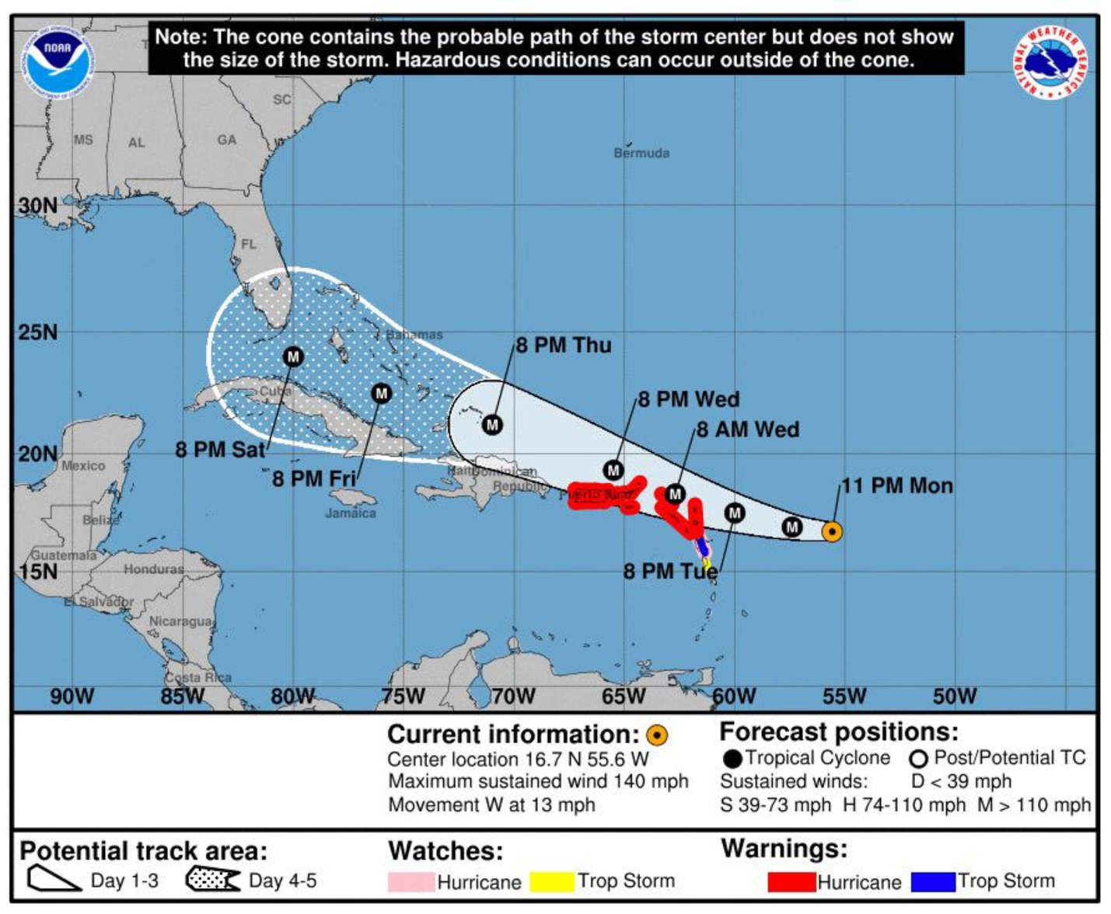

FIGURE 1. Example of a National Hurricane Center Cone graphic used in the survey. The name and date were removed to reduce the chances of association with a specific storm.

Corresponding Author: Scotney D. Evans, School of Education and Human Development, 5202 University Drive, Coral Gables, FL 33146. Email: s.evans4@miami.edu.

